 COSC 1320
Name: ________________ Terminal # __

Programming Assignment 3 C++ Acceptance Testing:
After you downloaded your zipped project from BB and rebuilt it using the 200 PGH Visual Studio 2010, download the “Programming Assignment 3 Acceptance Testing.doc”, and run the following test cases using the “Programming Assignment 3 Data.txt” provided in BlackBoard, take screenshots of the output produced, and insert it in this file ……..

1. Run the program using the original transactions
SCREENSHOT Output of your PROJECT is:
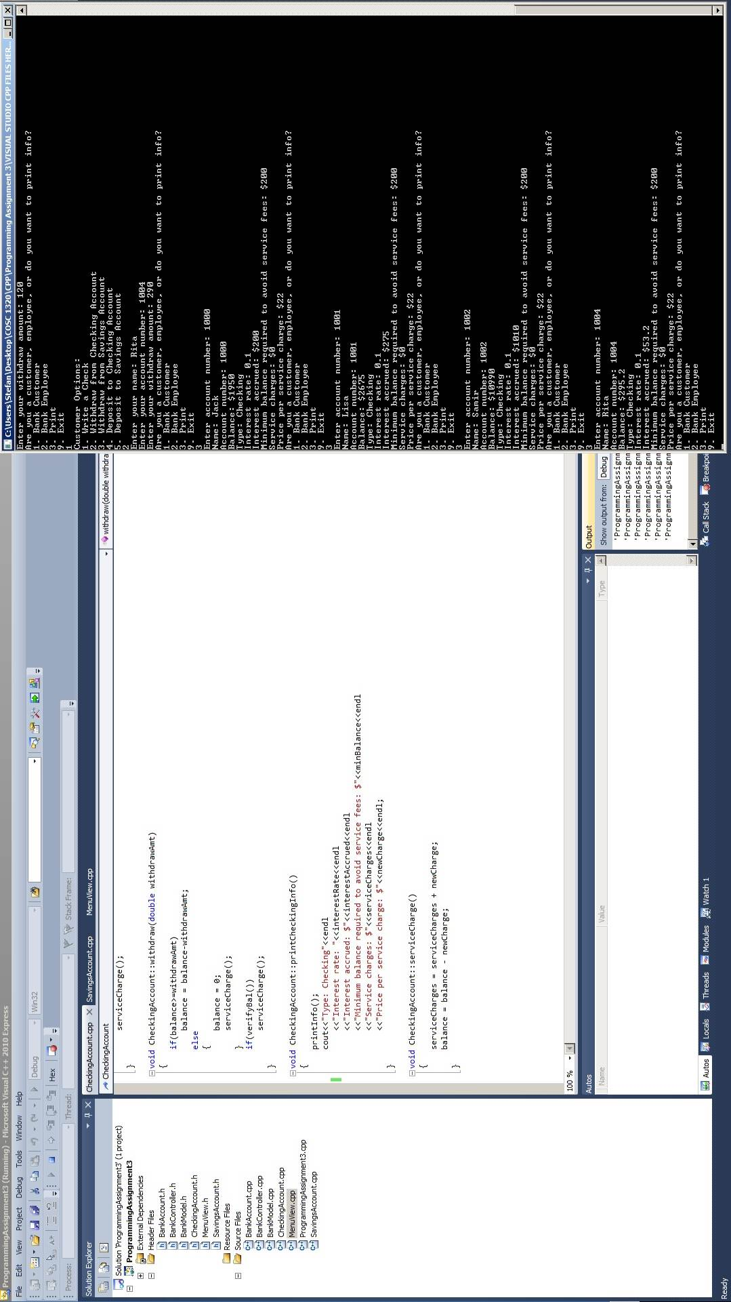
2. Run the program using the transactions given in Programming Assignment 3 Data.txt
SCREENSHOT Output of your PROJECT is:

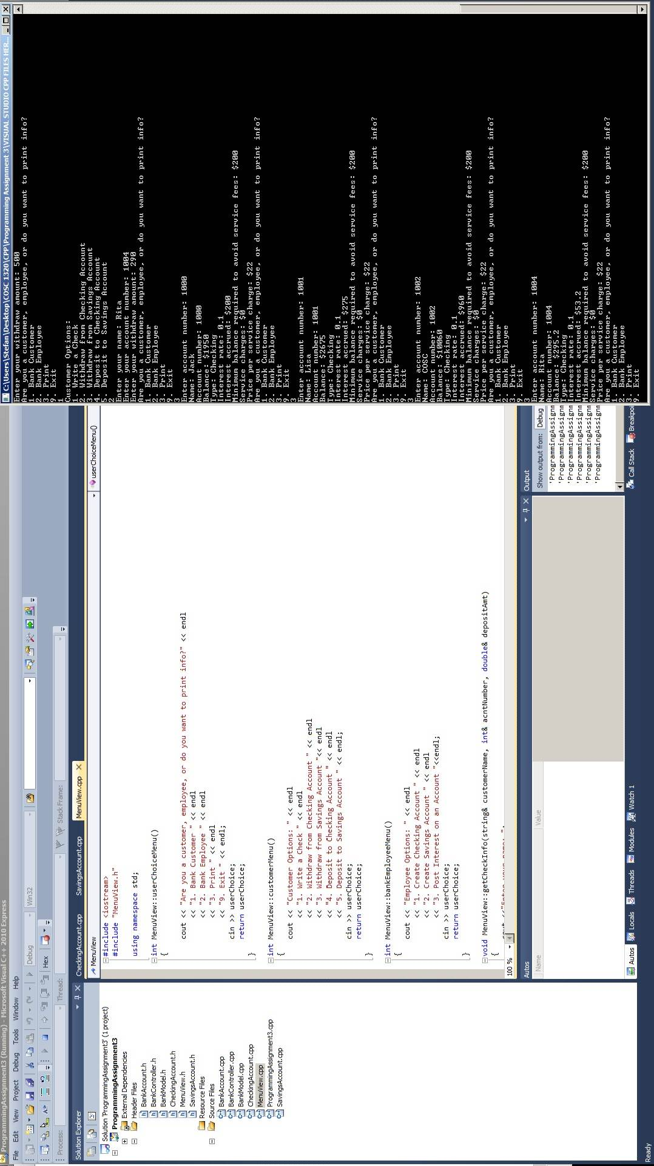
3. Copy and Paste your .h & .cpp files below:
ProgrammingAssignment3.cpp :

//ProgrammingAssignment3.cpp programming assignment 3
//cpp file for programming assignment 3
//Stefan Theard
//6/25/2013
#include <iostream>
#include <string>
#include "BankAccount.h"
#include "BankController.h"
#include "MenuView.h"

using namespace std;

int main()
{
int acntNumber, userChoice;
double amount;
string customerName;

MenuView view;
BankController controller = BankController();

do{
userChoice = -1;
acntNumber = 0;
customerName = "";
userChoice = view.userChoiceMenu();
if(userChoice == 1)
{
userChoice = view.customerMenu();
if(userChoice == 1)
{
view.getCheckInfo(customerName, acntNumber, amount);
if(!controller.writeCheck(acntNumber, amount))
view.accountNotFound();
}
else if(userChoice == 2)
{
view.getWithdrawInfo(customerName, acntNumber, amount);
if(!controller.checkingWithdraw(acntNumber, amount))
view.accountNotFound();
}
else if(userChoice == 3)
{
view.getDepositInfo(acntNumber, amount);
if(!controller.savingsWithdraw(acntNumber, amount))
view.accountNotFound();
}
else if(userChoice == 4)
{
view.getDepositInfo(acntNumber, amount);
if(!controller.checkingDeposit(acntNumber, amount))
view.accountNotFound();
}
else if(userChoice == 5)
{
view.getDepositInfo(acntNumber, amount);
if(!controller.savingsDeposit(acntNumber, amount))
view.accountNotFound();
}
}
else if(userChoice == 2)
{
userChoice = view.bankEmployeeMenu();
if(userChoice == 1)
{
view.getCustomerInfo(customerName, acntNumber, amount);
controller.createCheckingAccount(customerName, acntNumber, amount);
}
else if(userChoice == 2)
{
view.getCustomerInfo(customerName, acntNumber, amount);
controller.createSavingsAccount(customerName, acntNumber, amount);
}
else if(userChoice == 3)
{
view.getAccountNumInfo(acntNumber);
if(!controller.postInterest(acntNumber))
view.accountNotFound();
}
}
else if(userChoice == 3)
{
view.getAccountNumInfo(acntNumber);
controller.printAccountInfo(acntNumber);
}
}while(userChoice != 9);

return 0;
}

BankAccount.h :

//BankAccount.h programming assignment 3
//header file for programming assignment 3
//Stefan Theard
//6/25/2013
#ifndef BankAccount_H
#define BankAccount_H
#include <string>

using namespace std;

class BankAccount
{
protected:
int acntNum;
double balance;
string customerName;

public:
BankAccount();
void setName(string name); //1
void setAcntNum(int num); //2
int getAcntNum(); //3
double getBalance(); //4
void deposit(double amt); //5
void withdraw(double withdrawAmt); //6
void printInfo(); //7
};
#endif

BankAccount.cpp:

//BankAccount.cpp programming assignment 3
//cpp file for programming assignment 3
//Stefan Theard
//6/25/2013
#include <iostream>
#include <cstdlib>

#include "BankAccount.h"

using namespace std;

BankAccount::BankAccount()
{
acntNum = 0;
balance = 0;
customerName = "";
}

void BankAccount::setName(string name)
{
customerName = name;
}

void BankAccount::setAcntNum(int num)
{
acntNum = num;
}
int BankAccount::getAcntNum()
{
return acntNum;
}
double BankAccount::getBalance()
{
return balance;
}
void BankAccount::deposit(double depositAmt)
{
balance = balance + depositAmt;
}
void BankAccount::withdraw(double withdrawAmt) //TODO add error message if insufficient funds
{
balance = balance - withdrawAmt;
}
void BankAccount::printInfo()
{
cout<<"Name: "<<customerName<<endl
<<"Account number: "<<acntNum<<endl
<<"Balance: $"<<balance<<endl;

}

CheckingAccount.h :

//CheckingAccount.h programming assignment 3
//header file for programming assignment 3
//Stefan Theard
//6/25/2013
#ifndef CheckingAccount_H
#define CheckingAccount_H
#include "BankAccount.h"

class CheckingAccount : public BankAccount
{
private:
double interestRate, interestAccrued, minBalance, serviceCharges, newCharge;
bool verifyBal(); //8
void serviceCharge(); //12

public:
CheckingAccount();
void setRate(int newRate); //1
double getRate(); //2
void setMinBalance(double newMin); //3
double getMinBalance(); //4
void setSserviceCharges(double newCharges); //5
double getServiceCharges(); //6
void postInterest(); //7
void writeCheck(double checkAmt); //9
void withdraw(double withdrawAmt); //10
void printCheckingInfo(); //11

};
#endif

CheckingAccount.cpp :

//CheckingAccount.cpp programming assignment 3
//cpp file for programming assignment 3
//Stefan Theard
//6/25/2013
#include <iostream>
#include "BankAccount.h"
#include "CheckingAccount.h"

using namespace std;

CheckingAccount::CheckingAccount()
{
acntNum = 0;
balance = 0;
customerName = "";
interestRate = 0.10;
minBalance = 200;
serviceCharges = 0;
interestAccrued = 0;
newCharge = 22;
}

void CheckingAccount::setRate(int newRate){ interestRate = newRate;}

double CheckingAccount::getRate(){ return interestRate;}

void CheckingAccount::setMinBalance(double newMin){ minBalance = newMin;}

double CheckingAccount::getMinBalance(){ return minBalance;}

void CheckingAccount::setSserviceCharges(double newCharges){ serviceCharges = newCharges;}

double CheckingAccount::getServiceCharges(){ return serviceCharges;}

void CheckingAccount::postInterest()
{
interestAccrued = interestRate*balance;
balance = balance + interestAccrued;
}

bool CheckingAccount::verifyBal()
{
return (balance<minBalance); //TODO : verify correctness on bool here
}

void CheckingAccount::writeCheck(double checkAmt) //TODO : figure out if writeCheck can go negative
{ // and if it can what response is done, service charge?
balance = balance - checkAmt;
if(verifyBal())
serviceCharge();
if(balance<0)
serviceCharge();
}

void CheckingAccount::withdraw(double withdrawAmt)
{
if(balance>=withdrawAmt)
balance = balance-withdrawAmt;
else
{
balance = 0;
serviceCharge();
}
if(verifyBal())
serviceCharge();
}

void CheckingAccount::printCheckingInfo()
{
printInfo();
cout<<"Type: Checking"<<endl
<<"Interest rate: "<<interestRate<<endl
<<"Interest accrued: $"<<interestAccrued<<endl
<<"Minimum balance required to avoid service fees: $"<<minBalance<<endl
<<"Service charges: $"<<serviceCharges<<endl
<<"Price per service charge: $"<<newCharge<<endl;
}

void CheckingAccount::serviceCharge()
{
serviceCharges = serviceCharges + newCharge;
balance = balance - newCharge;
}

SavingsAccount.h :

//SavingsAccount.h programming assignment 3
//header file for programming assignment 3
//Stefan Theard
//6/25/2013
#include "BankAccount.h"

class SavingsAccount : public BankAccount
{
private:
double interestRate, interestAccrued;

public:
SavingsAccount();
void setRate(int newRate); //1
double getRate(); //2
void postInterest(); //3
void printSavingsInfo(); //4
};

SavingsAccount.cpp :

//SavingsAccount.cpp programming assignment 3
//cpp file for programming assignment 3
//Stefan Theard
//6/25/2013
#include <iostream>
#include "BankAccount.h"
#include "SavingsAccount.h"

using namespace std;

SavingsAccount::SavingsAccount()
{
interestRate = 0.10;
interestAccrued = 0;
balance = 0;
customerName = "";
}

void SavingsAccount::setRate(int newRate){
interestRate = newRate;
}

double SavingsAccount::getRate(){
return interestRate;
}

void SavingsAccount::postInterest()
{
interestAccrued = interestRate*balance;
balance = balance + interestAccrued;
}

void SavingsAccount::printSavingsInfo()
{
printInfo();
cout<<"Type: Savings"<<endl
<<"Interest rate: "<<interestRate<<endl
<<"Interest accrued: $"<<interestAccrued<<endl;
}

BankController.h :

//BankController.h programming assignment 3
//header file for programming assignment 3
//Stefan Theard
//6/25/2013
#include "BankAccount.h"
#include "BankModel.h"
class BankController
{
private:
BankModel bankModel;

public:
bool postInterest(int acntNumber); //uc1
void createCheckingAccount(string customerName, int acntNumber, double amount); //uc2
bool checkingDeposit(int acntNumber, double amount); //uc3
bool checkingWithdraw(int acntNumber, double amount); //uc4
bool writeCheck(int acntNumber, double amount); //uc5
bool printAccountInfo(int acntNumber); //uc6
void createSavingsAccount(string customerName, int acntNumber, double amount); //uc7
bool savingsDeposit(int acntNumber, double amount); //uc8
bool savingsWithdraw(int acntNumber, double amount); //uc9
};

BankController.cpp :

//BankController.cpp programming assignment 3
//cpp file for programming assignment 3
//Stefan Theard
//6/25/2013
#include "BankController.h"

void BankController::createCheckingAccount(string customerName, int acntNumber, double amount)
{
bankModel.createCheckingAccount(customerName, acntNumber, amount);
}

void BankController::createSavingsAccount(string customerName, int acntNumber, double amount)
{
bankModel.createSavingsAccount(customerName, acntNumber, amount);
}

bool BankController::printAccountInfo(int acntNumber)
{
return bankModel.printAccountInfo(acntNumber);
}

bool BankController::postInterest(int acntNumber)
{
return bankModel.postInterest(acntNumber);
}

bool BankController::checkingDeposit(int acntNumber, double amount)
{
return bankModel.checkingDeposit(acntNumber, amount);
}

bool BankController::savingsDeposit(int acntNumber, double amount)
{
return bankModel.savingsDeposit(acntNumber, amount);
}

bool BankController::checkingWithdraw(int acntNumber, double amount)
{
return bankModel.checkingWithdraw(acntNumber, amount);
}

bool BankController::savingsWithdraw(int acntNumber, double amount)
{
return bankModel.savingsWithdraw(acntNumber, amount);
}

bool BankController::writeCheck(int acntNumber,double amount)
{
return bankModel.writeCheck(acntNumber, amount);
}

BankModel.h :

//BankModelt.h programming assignment 3
//header file for programming assignment 3
//Stefan Theard
//6/25/2013
#include <string>
#include "BankAccount.h"
#include "CheckingAccount.h"
#include "SavingsAccount.h"
using namespace std;

class BankModel
{
private:
CheckingAccount checkingAccount[200];
SavingsAccount savingsAccount[200];

public:
void createCheckingAccount(string customerName, int acntNumber, double amount);
void createSavingsAccount(string customerName, int acntNumber, double amount);
bool printAccountInfo(int acntNumber);
bool postInterest(int acntNumber);
bool checkingDeposit(int acntNumber, double amount);
bool savingsDeposit(int acntNumber, double amount);
bool checkingWithdraw(int acntNumber, double amount);
bool savingsWithdraw(int acntNumber, double amount);
bool writeCheck(int acntNumber, double amount);
};

BankModel.cpp :

//BankModel.cpp programming assignment 3
//cpp file for programming assignment 3
//Stefan Theard
//6/25/2013
#include <string>
#include "BankModel.h"
using namespace std;

void BankModel::createCheckingAccount(string customerName, int acntNumber, double amount)
{
for(int i = 0; i<200; i++)
{
if(checkingAccount[i].getAcntNum() == 0)
{
checkingAccount[i].setAcntNum(acntNumber);
checkingAccount[i].setName(customerName);
checkingAccount[i].deposit(amount);
return;
}
}
}

void BankModel::createSavingsAccount(string customerName, int acntNumber, double amount)
{
for(int i = 0; i<200; i++)
{
if(savingsAccount[i].getAcntNum() == 0)
{
savingsAccount[i].setAcntNum(acntNumber);
savingsAccount[i].setName(customerName);
savingsAccount[i].deposit(amount);
return;
}
}
}

bool BankModel::printAccountInfo(int acntNumber)
{
int i;
for(i = 0; i<200; i++)
{
if(savingsAccount[i].getAcntNum() == acntNumber)
savingsAccount[i].printSavingsInfo();
if(checkingAccount[i].getAcntNum() == acntNumber)
checkingAccount[i].printCheckingInfo();
}
if(i == 199)
return false;
return true;
}

bool BankModel::postInterest(int acntNumber)
{
int i;
for(i = 0; i<200; i++)
{
if(savingsAccount[i].getAcntNum() == acntNumber)
savingsAccount[i].postInterest();
if(checkingAccount[i].getAcntNum() == acntNumber)
checkingAccount[i].postInterest();
}
if(i == 199)
return false;
return true;
}

bool BankModel::checkingDeposit(int acntNumber, double amount)
{
for(int i = 0; i<200; i++)
{
if(checkingAccount[i].getAcntNum() == acntNumber)
{
checkingAccount[i].deposit(amount);
return true;
}
}
return false;
}

bool BankModel::savingsDeposit(int acntNumber, double amount)
{
for(int i = 0; i<200; i++)
{
if(savingsAccount[i].getAcntNum() == acntNumber)
{
savingsAccount[i].deposit(amount);
return true;
}
}
return false;
}

bool BankModel::checkingWithdraw(int acntNumber, double amount)
{
for(int i = 0; i<200; i++)
{
if(checkingAccount[i].getAcntNum() == acntNumber)
{
checkingAccount[i].withdraw(amount);
return true;
}
}
return false;
}

bool BankModel::savingsWithdraw(int acntNumber, double amount)
{
for(int i = 0; i<200; i++)
{
if(savingsAccount[i].getAcntNum() == acntNumber)
{
savingsAccount[i].withdraw(amount);
return true;
}
}
return false;
}

bool BankModel::writeCheck(int acntNumber, double amount)
{
for(int i = 0; i<200; i++)
{
if(checkingAccount[i].getAcntNum() == acntNumber)
{
checkingAccount[i].writeCheck(amount);
return true;
}
}
return false;
}

MenuView.h :

//MenuView.h programming assignment 3
//header file for programming assignment 3
//Stefan Theard
//6/25/2013
#include <string>
using namespace std;
class MenuView
{
public:
int userChoiceMenu(); //1
int customerMenu(); //2
int bankEmployeeMenu(); //3
void getCheckInfo(string& customerName, int& acntNumber, double& amount); //4
void getWithdrawInfo(string& customerName, int& acntNumber, double& amount); //5
void getDepositInfo(int& acntNumber, double& amount); //6
void getCustomerInfo(string& customerName, int& acntNumber, double& amount); //7
void getAccountNumInfo(int& acntNumber); //8
void accountNotFound(); //9
private:
int userChoice;
};

MenuView.cpp :

//MenuView.cpp programming assignment 3
//cpp file for programming assignment 3
//Stefan Theard
//6/25/2013
#include <iostream>
#include "MenuView.h"

using namespace std;

int MenuView::userChoiceMenu()
{

cout << "Are you a customer, employee, or do you want to print info?" << endl
<< "1. Bank Customer " << endl
<< "2. Bank Employee " << endl
<< "3. Print " << endl
<< "9. Exit " << endl;
cin >> userChoice;
return userChoice;
}

int MenuView::customerMenu()
{
cout << "Customer Options: " << endl
<< "1. Write a Check " << endl
<< "2. Withdraw from Checking Account " << endl
<< "3. Withdraw from Savings Account "<< endl
<< "4. Deposit to Checking Account " << endl
<< "5. Deposit to Savings Account " << endl;
cin >> userChoice;
return userChoice;
}

int MenuView::bankEmployeeMenu()
{
cout << "Employee Options: " << endl
<< "1. Create Checking Account " << endl
<< "2. Create Savings Account " << endl
<< "3. Post Interest on an Account "<<endl;
cin >> userChoice;
return userChoice;
}

void MenuView::getCheckInfo(string& customerName, int& acntNumber, double& depositAmt)
{
cout <<"Enter your name: ";
cin >> customerName;
cout << "Enter your account number: ";
cin >> acntNumber;
cout << "Enter your check amount: ";
cin >> depositAmt;
}

void MenuView::getWithdrawInfo(string& customerName, int& acntNumber, double& amount)
{
cout <<"Enter your name: ";
cin >> customerName;
cout << "Enter your account number: ";
cin >> acntNumber;
cout << "Enter your withdraw amount: ";
cin >> amount;
}

void MenuView::getDepositInfo(int& acntNumber, double& amount)
{
cout << "Enter your account number: ";
cin >> acntNumber;
cout << "Enter your deposit amount: ";
cin >> amount;
}

void MenuView::getCustomerInfo(string& customerName, int& acntNumber, double& amount)
{
cout <<"Enter customer name: ";
cin >> customerName;
cout << "Enter account number for customer: ";
cin >> acntNumber;
cout << "Enter customers initial deposit amount: ";
cin >> amount;
}

void MenuView::getAccountNumInfo(int& acntNumber)
{
cout << "Enter account number: ";
cin >> acntNumber;
}

void MenuView::accountNotFound()
{
cout << "Account not found!" << endl;
}

